Project Plan
ReserveIT

Date : Date
Version : Version
State : State
Author : Author

Version history

Version | Date | Author(s) | Changes | State
1.0 | Sept 2024 | Ivaylo Slavov | Initial version | Open for Review

Distribution
Version | Date | Receivers

Contents
1. Project assignment 4
1.1 Context 4
1.2 Goal of the project 4
1.3 Scope and preconditions 4
1.4 Strategy 4
1.5 Research questions 4
1.6 End products 4
2. Project Organisation 6
2.1 Stakeholders and team members 6
2.2 Communication 6
3. Activities and time plan 7
3.1 Phases of the project 7
3.2 Time plan and milestones 7
4. Testing strategy and configuration management 8
4.1 Testing strategy 8
4.2 Test environment and required resources 8
4.3 Configuration management 8
5. Finances and Risk 9
5.1 Project budget 9
5.2 Risk and mitigation 9

Project assignment

Context
This project entails the creation of a Restaurant Table Reservation and Management System, which will provide a streamlined platform for consumers, employees, and restaurant owners to manage table bookings. The project's main goals are to make online reservations for tables easier, manage seating for personnel, and aggregate data for restaurant management.

Goal of the project

The goal is to build a full-stack application that supports:
- Customers: Make and manage table reservations.
- Staff: View and modify reservations, handle seating arrangements.
- Administrators/Managers: Manage tables, view aggregated data such as customer traffic, and receive real-time updates.
Advantages include:
- Improved customer experience through an easy reservation process.
- Efficient management of seating and reservations by staff.
- Data-driven decisions based on aggregated metrics for managers.

Scope and preconditions

Inside scope: | Outside scope:
- Table reservations (CRUD operations) | - Food ordering
- User management (Admin, Staff, Customers) | - Billing and invoicing system
- Real-time updates using WebSockets | - Kitchen operations
- Backend for managing reservations and tables
- Data aggregation (e.g., total customers per week)

Preconditions:
- Tech stack: React for frontend, Spring Boot for backend, JPA/Hibernate as ORM, and MySQL database.
- Agile methodology with 3-week sprints.

Strategy
The project will follow an Agile approach, using 3-week sprints. The Agile methodology allows for incremental delivery and regular feedback from potential users and stakeholders. Each sprint will focus on delivering small functional parts of the system and integrating them into the larger system. The final sprint will focus on refining the system, testing, and deployment.

Research questions and methodology
In this project, we will address several important research questions using methodologies suited to each phase of development, based on the Dot Framework.
- How can WebSockets be integrated for real-time reservation updates?
  - Methodology:
    - Workshop: Code reviews and brainstorming sessions to find the best approach for WebSocket integration.
    - Lab: Conduct unit testing and system testing to ensure WebSocket reliability and performance in handling real-time updates.
- What is the best way to aggregate data for reservation reports and insights?
  - Methodology:
    - Library: Literature study on data aggregation techniques in databases like MySQL.
    - Field: Interview restaurant staff to understand what kind of reports (e.g., busiest times, total reservations) would be most useful.
- How can the user interface be designed to be easy and intuitive for customers and staff?
  - Methodology:
    - Workshop: Brainstorm UI/UX designs through mockups and prototypes.
    - Showroom: Usability testing to gather feedback and improve the design based on user experience.
- How can secure authentication and authorization be implemented?
  - Methodology:
    - Library: Research best practices for implementing role-based access control with JWT.
    - Lab: Test the security and functionality of the authentication and authorization system through unit and integration tests.
- How can we ensure data privacy and compliance with regulations like GDPR?
  - Methodology:
    - Library: Research GDPR guidelines and data protection practices.
    - Field: Discuss with legal or compliance experts to ensure that the system follows privacy regulations.

End products
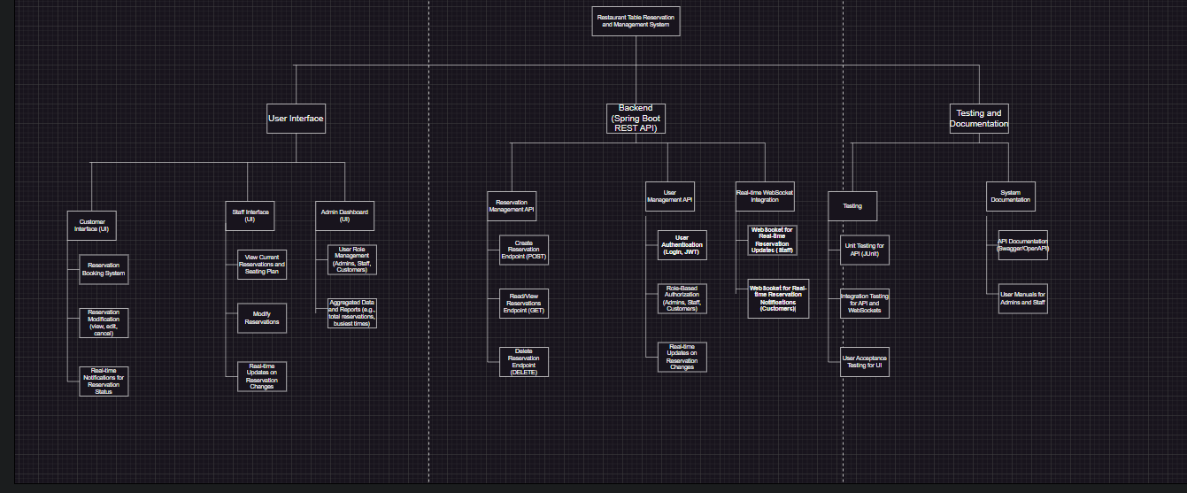

Project organisation

Stakeholders and team members

Name | Abbreviation | Role and functions | Availability
Ivaylo Slavov | I.S. | Full-stack Dev  Databases  Project Manager | Every day
Boelaars,Marcel  Snoeren,Jacco |  | Client  Client

Communication

2.2 Communication
- Internal Communication: Email, Slack, Jira for task management and tracking.
- Stand-up Meetings: Weekly check-ins for progress tracking.
- Sprint Reviews: Every three weeks reviews to assess the progress and make necessary changes.

Activities and time plan

Phases of the project
• Sprint 1 (Planning & Requirements Gathering)
- Focus on gathering high-level requirements and user stories.
- Identify key features for the first sprint.
- Set up the project environment (version control, CI/CD).
- Deliverable: Basic project setup and initial user stories.

• Sprint 2 (Backend Setup & Initial API Development)
- Develop the initial backend infrastructure using Spring Boot.
- Implement basic CRUD operations for the reservations system.
- Set up the database schema.
- Deliverable: Working backend with reservation CRUD operations.

• Sprint 3 (Frontend Setup & Integration)
- Develop the initial frontend interface using React.
- Integrate the frontend with the backend APIs.
- Focus on user interaction for reservations.
- Deliverable: Basic frontend interface integrated with backend APIs.

• Sprint 4 (User Authentication & Role Management)
- Implement user authentication and authorization (Admin, Staff, Customer).
- Focus on secure login and role-based access control.
- Deliverable: Secure login system and role-based access.

• Sprint 5 (WebSocket Integration & Real-time Updates)
- Integrate WebSockets for real-time updates on reservations.
- Implement notification systems for staff and customers.
- Deliverable: Working WebSocket system for live updates.

• Sprint 6 (Data Aggregation & Reporting)
- Implement data aggregation (e.g., customer traffic, table occupancy).
- Provide insights and reports for administrators.
- Deliverable: Data aggregation and reporting dashboard.

• Sprint 7 (Final Testing, Bug Fixing & Optimization)
- Conduct full-system testing (unit, integration, and user acceptance).
- Fix bugs and optimize performance.
- Deliverable: Fully tested and optimized system.

• Sprint 8 (Deployment & Final Adjustments)
- Deploy the system to a staging or production environment.
- Perform final adjustments based on user feedback.
- Deliverable: Deployed system ready for users.

Testing strategy and configuration management

Testing strategy

We will follow a structured testing approach to ensure that all parts of the system function as expected:

Unit Testing: Test individual components and modules, aiming for 80% coverage.

Integration Testing: Test interactions between different parts of the system, ensuring proper communication between the frontend and backend.

User Acceptance Testing: Real users (restaurant staff, admins) will test the system for usability, functionality, and reliability.

Test environment and required resources

The test environment will include:
- A local development environment for building and testing the system.
- A staging environment to simulate production, allowing us to test under real-world conditions before deployment.

Configuration management
We will use Git for version control, with a clear branching strategy:
- Main branch: Production-ready code.
- Development branch: Active development and feature integration.
- Feature branches: Separate branches for specific features, merged after code review.

Finances and risk

Project budget

There are no major budget requirements since the project uses open-source tools (Spring Boot, React, MySQL).

Risk and mitigation

Risk | Prevention activities | Mitigation activities
- Feature scope creep | Clearly define project requirements and regularly review progress to avoid adding unnecessary features. | If scope expansion is necessary, prioritize critical features and rescope non-essential functionalities to future sprints.
- WebSocket integration complexity | Research and implement WebSocket prototypes early in development to identify potential challenges. | If issues arise with WebSockets, fall back to alternative real-time solutions
- Time management issues | Use sprint planning and set realistic timelines for each development phase, regularly reviewing progress. | Reallocate resources from less critical tasks to high-priority features and consider trimming features that are less essential.

